Launch Pad Concept- Mark 1.
We have thought of a way to make a modular launch pad, to basically allow as many rockets as we want to launch from it. It has a 4-way PVC pipe connector as its central node to which 2 45° elbows can be connected. At the end of the elbow connectors we will attach rebars in order to be able to stick the launchpad to the ground and provide stability for the launch platform.
The Launch Rod will be a 2m long Carbon fiber rod that will be attached in the middle of the central node, through a drilled hole.
Below are the pictures of the individual parts and places where they can be bought, although we believe its best if we just go to a hardware store and buy the pvc and rebar parts. The carbon fibre rods will probably have to be purchased online.
PVC pipe connector
https://www.ebay.co.uk/itm/186148697815
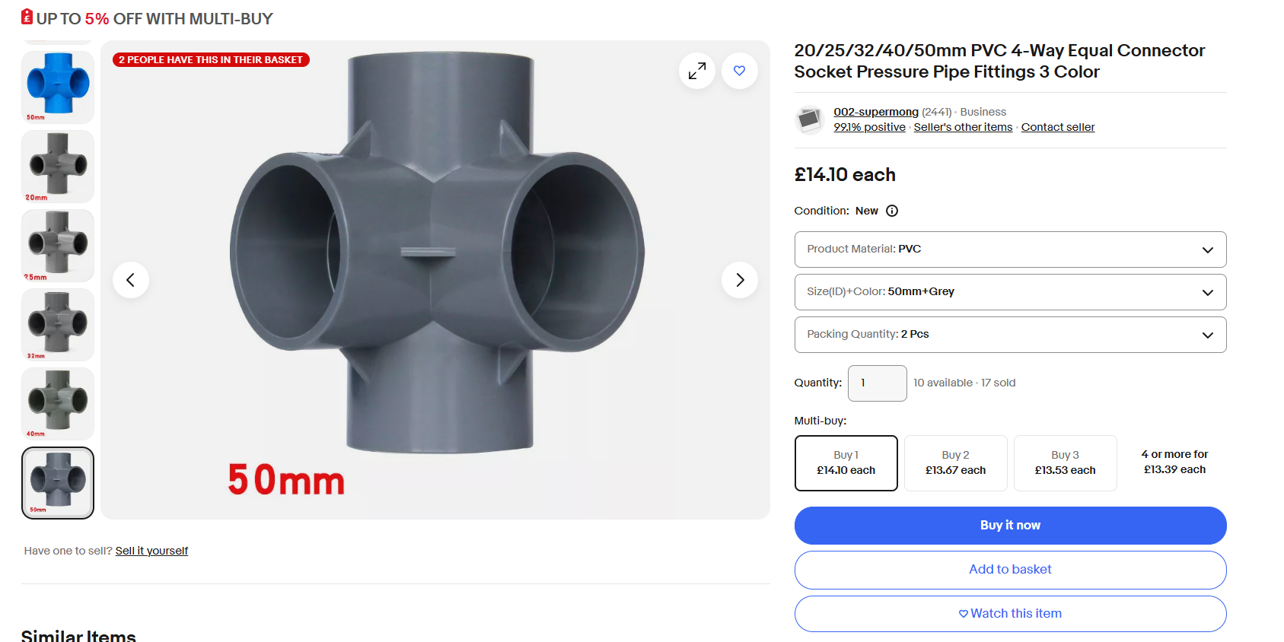
Figure 1: 4 Way PVC pipe connector/central Node.

Carbon Fibre Launch Rod
The website allows for a range of thicknesses and lengths, as suggested by Rufus, the thickness of it should be 3mm and a height of 1m. We selected the 2m option as part of the rod will go through and into the ground as demonstrated in fig 5 and 6.
https://www.plastock.co.uk/products/carbon-fibre-rod?variant=43847590019296
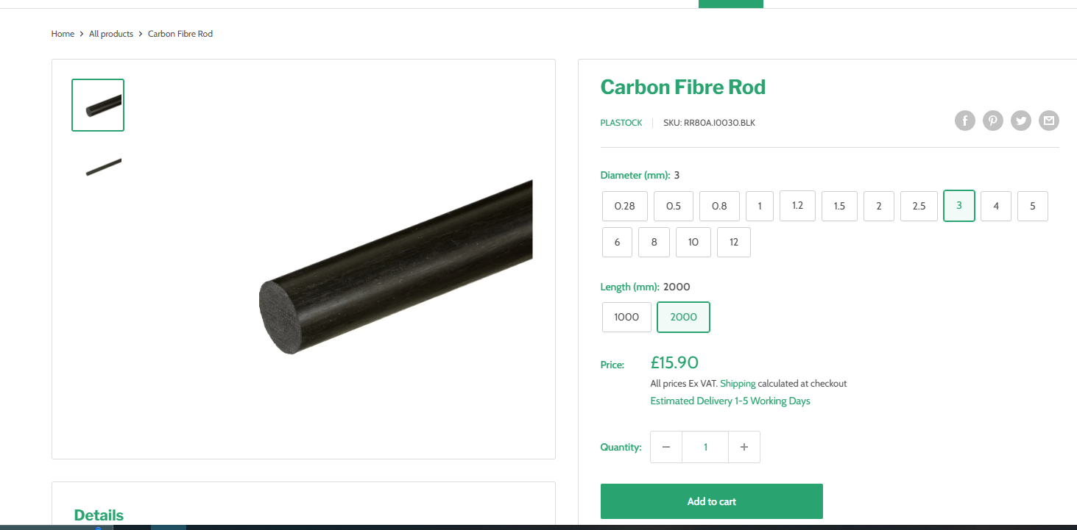
Figure 2: Carbon Fibre launch Rod.

45° Elbow connector.
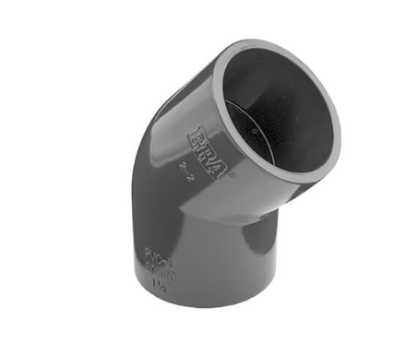
Figure 3: 45° elbow connector
https://www.plasticpipeshop.co.uk/34-Plain-45-Degree-PVC-Elbow_p_651.html
This probably isn´t the right thickness to fit with the central node but as our plan is to go to a hardware shop and buy the pvc parts we can do fit testing there as we are buying them.
Rebar ground inserts
https://www.themetalstore.co.uk/products/rebar-reinforcing-bar?gad_source=1&gclid=Cj0KCQiAire5BhCNARIsAM53K1gzAel7Tf72IMZnOQzw7WbN_kDHrsJnCzI74yCnnwL6kc58tqcW7s8aAn5XEALw_wcB
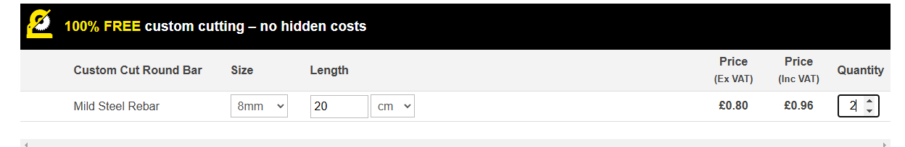
From this website it appears that the rebars are quite cheap. We want the rebar to be relatively thin so its not difficult to stick it in the ground. Since the rebar will be thinner than the pvc elbow it needs to connect to we need to design a connector piece.

Assembled PVC launcher.
We found an online CAD software specifically designed for PVC pipe fittings, how great is that! The PVC pipes after the 45º elbows are just placeholders to visualize how the rebars will dig into the ground, in the actual design we will have the rebar rods there.
https://make.craftyamigo.com/design/NFzoQ72ZlGa9n0PxkDMMKmCpqPt2/Ez62fsj9WnpzypeiIMrv
Ground
Figure 4: Single PVC launcher.

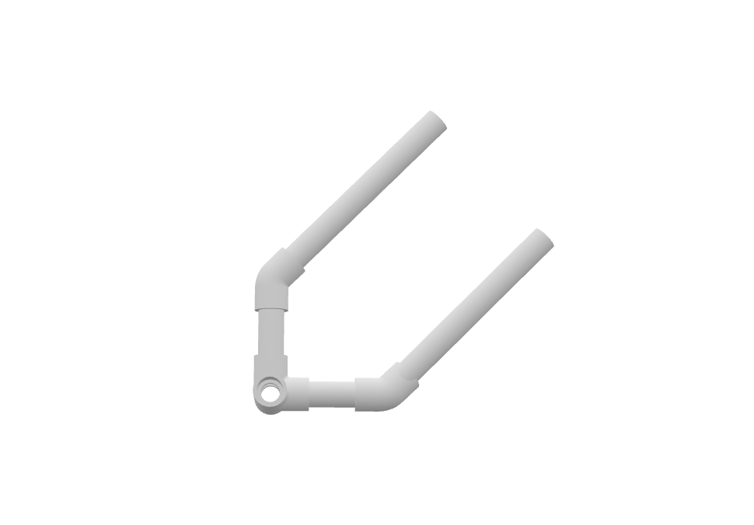

Figure 5: The black thing is the Carbon fibre rod.

Demonstrating the modularity

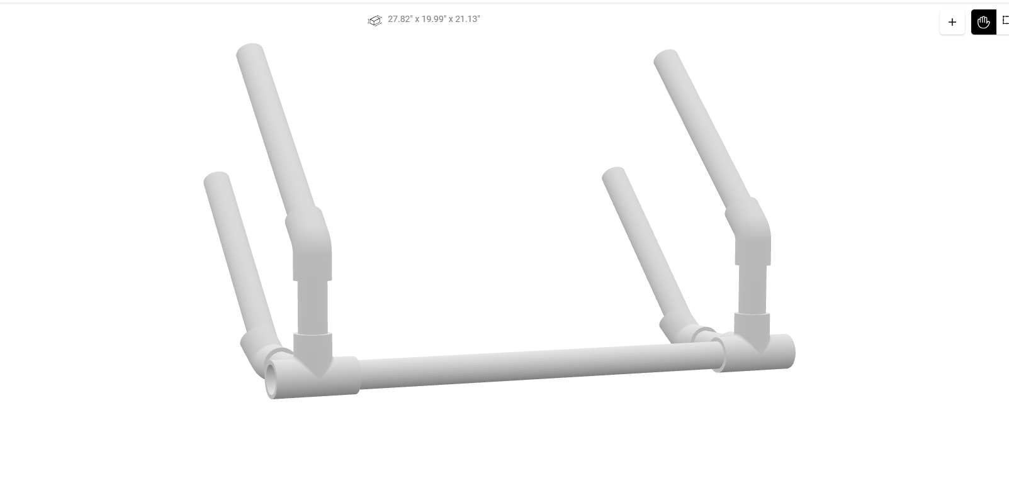
Figure 6: 2 Rocket Launcher configuration
Looking at figure 6 we can see how it is possible to assemble a launchpad capable of launching as many rockets as we want, all we need is to make more of the support parts.

